Name-Aditi Sudhir Igade

Div-A Roll no-221081

PRN. No-22220311

Assignment 1

**Problem Statement-**

WAP in java that calculates the grade of N students based on the marks entered by user in each subject.

Program prints the grade based on this logic. If the average of marks is >= 80 then prints Grade ‘A’ If the

average is <80 and >=60 then prints Grade ‘B’ If the average is <60 and >=40 then prints Grade ‘C’ else

prints Grade ‘D’.

**Aim**- To calculate the grade of n student for 4 subjects.

**OBJECTIVE: -**

To write a program to calculate grade of N students by applying object-oriented concepts of class and Object.

## Theory-

An object is an instance of a class. A class is a template or blueprint from which objects are created. So, an object is the instance(result) of a class. Object-Oriented Programming is a methodology or paradigm to design a program using classes and objects.

**ALGORITHM:-**

1. Create Student Class
2. Declare variables marks, average, grade
3. Accept marks for student for n subjects.
4. Calculate average of n subjects.
5. Calculate grade for a student
6. Display the grade for a student

**Code**-

package com;

import java.util.Scanner;

import java.util.InputMismatchException;

class Calc{

float avg;

public void average(int a,int b,int c,int d){

avg=(a+b+c+d)/4f;

System.out.println("The average of subjects is="+avg);

}

public void grade(){

if(avg>=80){

System.out.println("The grade obtained is=A\n");

}

else if(avg>=60 && avg<80){

System.out.println("The grade obtained is=B\n");

}

else if(avg>=40 && avg<60){

System.out.println("The grade obtained is=C\n");

}

else{

System.out.println("The grade obtained is=D\n");

}

}

}

public class Assign1

{

public static void main(String[] args) {

Scanner sc=new Scanner(System.in);

System.out.println("==================Grade Calculator==============");

System.out.println("Enter the number of student");

int n=sc.nextInt();

if(n==0){

System.out.println("Class doesn't exist");

}

else{

try {

int count=1;

for(int i=0;i<n;i++){

System.out.println("Enter the marks of student "+count);

System.out.println("Enter the marks of CAO-");

int cao=sc.nextInt();

System.out.println("Enter the marks of OOP-");

int oop=sc.nextInt();

System.out.println("Enter the marks of DM-");

int dm=sc.nextInt();

System.out.println("Enter the marks of ADE-");

int ade=sc.nextInt();

System.out.println("CAO ="+cao);

System.out.println("OOP ="+oop);

System.out.println("DM ="+dm);

System.out.println("ADE ="+ade);

Calc obj=new Calc();

obj.average(cao,oop,dm,ade);

obj.grade();

count++;

}}

catch (InputMismatchException ex) {

System.out.println("Please enter a number");

}

}

}

}

**OUTPUT-**

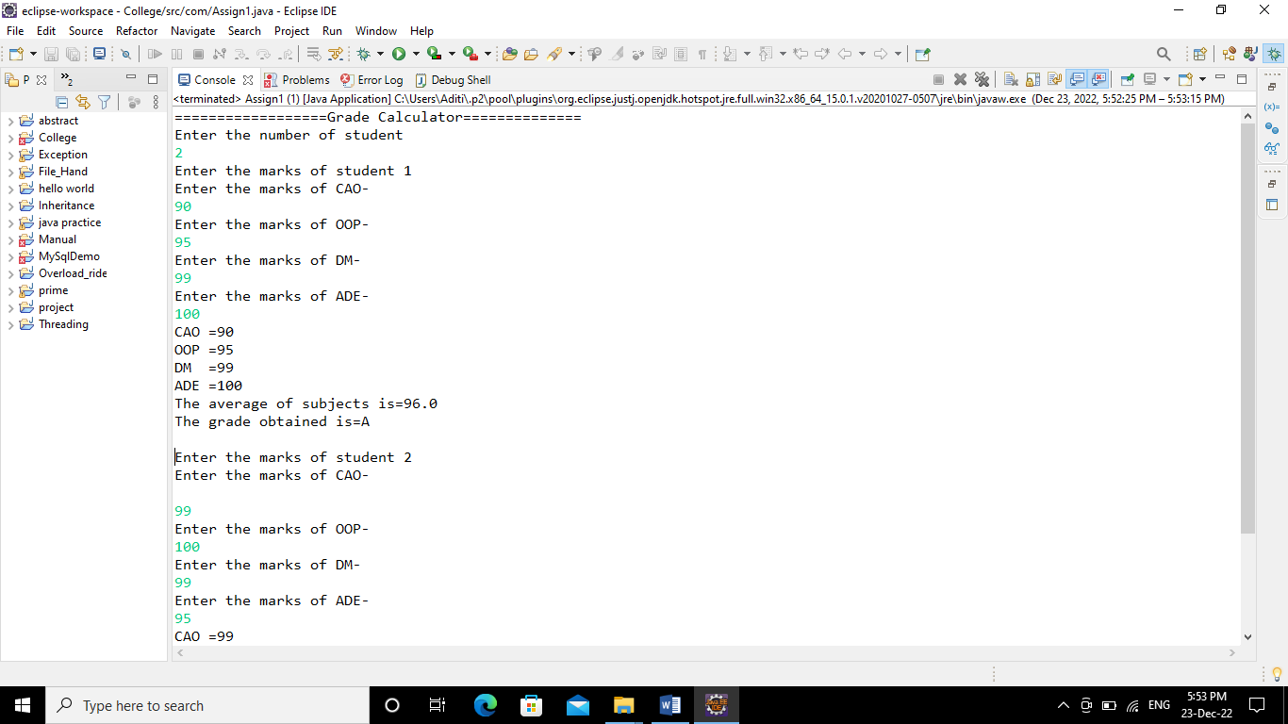

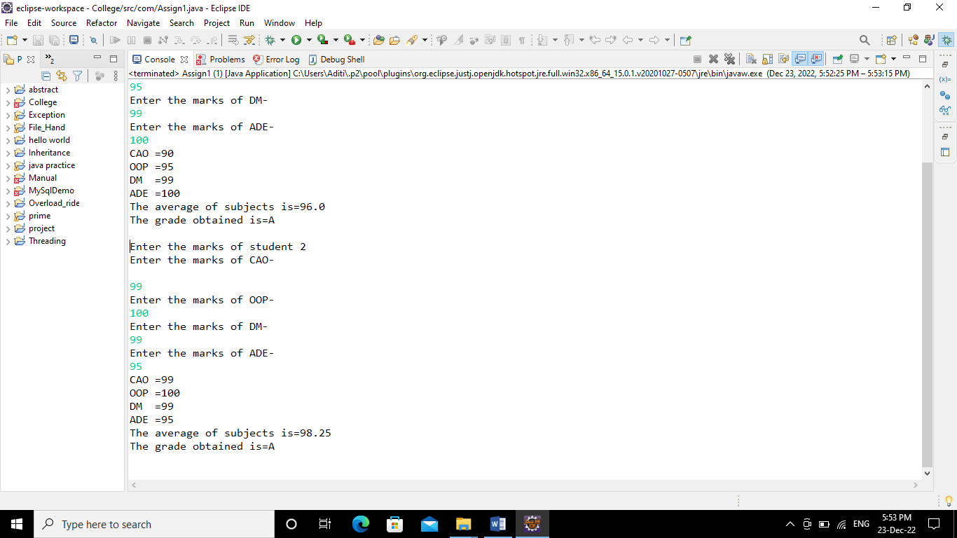

**CONCLUSION:-**

Able to apply the object oriented concepts of class and object to calculate average and grade of students.